THING 1 – Assessment – Evaluation
What are rubrics – assesses Performance to Quality
http://rubistar.4teachers.org/index.php
Create login
Find rubric – CIVIL WAR POWERPOINT
(SEARCH OPTIONS: AND search type (all words must match) – results 49 hits
OR search type (any words must match) – results 13798
Locate one, click on it and view, PRINT THE PAGE
Create rubric
Categories: Oral Projects, Products, Multimedia, Science, Research Writing, Work Skills, Math, Art, Music, Reading
Select Multimedia, Powerpoint/Hyperstudio
WARNING – 40 MINUTES
Rubric Description
Rubric Project Name
Verify zip code
DEMONSTRATION RUBRIC = NO MY RUBRIC IS PERMAMENT
Creating rubric
click on a couple, note scale is automatic, rows can be edited, scroll to bottom SUBMIT
NOTE RUBRIC IS NOT SAVED – BEFORE MODIFYING, SCROLL TO BOTTOM AND MAKE AVAILABLE ONLINE, note RUBRIC ID
RETURN TO TEACHER HOME

Edit Rubric
Click on link to rubric – note ANALYZE, EDIT, SAVE RUBRIC, PRINT PAGE
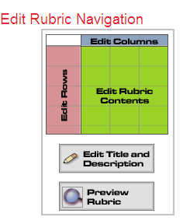
Edit Rubric Navigation
Edit Columns – CHANGE scale or categories (ex: 4,3,2,1 – adding a 0 to the scale)
Edit Rubric Row Names – CHANGE order of rows, add a row (ex: adding Content)
Edit Rubric Contents – (ex: adding 0 = NO ATTEMPT, adding Content = Missing no key elements, missing 1-2 key elements, missing 3-4 key elements, missing 5-6 key elements)
Edit title and description
Preview rubric

Return to TEACHER HOME, select rubric we are working with
Save (Excel)
Analyze –show entry of student information

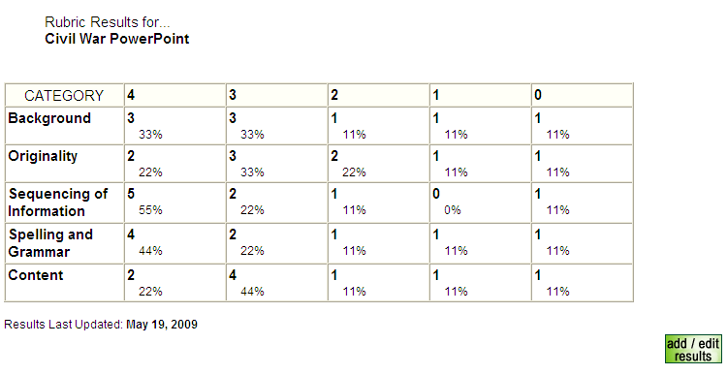
Logout/log back in and locate rubric
SURVEY MONKEY
Create online surveys – set up a free account
http://www.surveymonkey.com
Create account
Create Survey
Edit Survey/Design Survey
Change theme – from Spring Day to Blue Ice
Add question 1
Multiple Choice, one answer
Display choices as a drop down menu
Question: How valuable is a computer in your classroom?
Answers: extremely valuable, very valuable, somewhat valuable, not valuable, no opinion
Discuss: sort/randomize choices, comment field, require answer to question
Add Comment: What kinds of technology should be in every K-12 classroom?
X - Require Answer, Save Changes
Add question 2
Save Changes
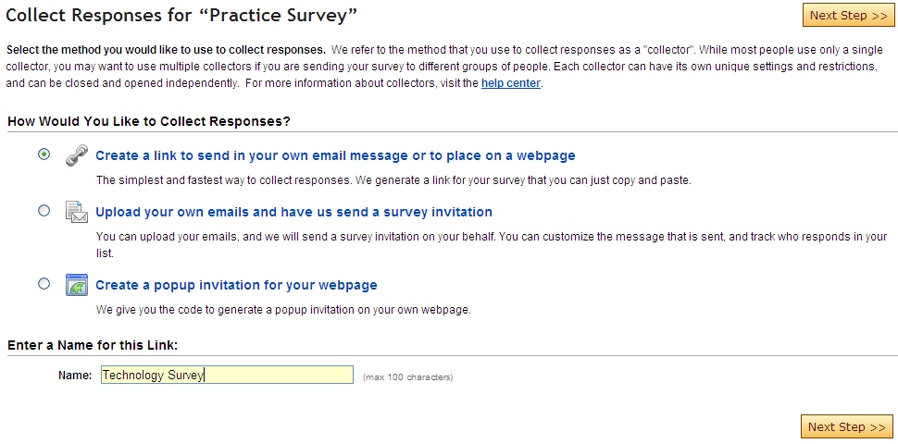
MOVE QUESTION
Collect Responses
Create link, Upload your email and have SM send invitation, create popup invitation for webpage

Check Settings
Number of responses per computer, clicking Back, Save IP addresses --- BACK TO SUMMARY
Check Restrictions
Cutoff Date, Max Response count, enable password protection, enable IP blocking --- BACK TO SUMMARY

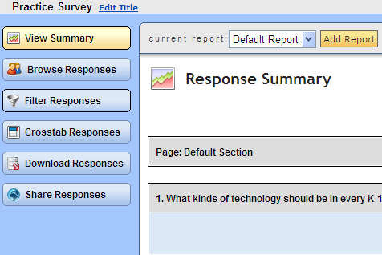
Analyze results
View Summary and Browse Responses are the only options with FREE VERSION.
Open new browser; copy web address of survey to new address bar in new browser; take survey; return to response summary, Refresh (f5), see responses

CAN’T PRINT OR EXPORT SURVEY EXCEPT PRINTING IN A WEB BROWSER.
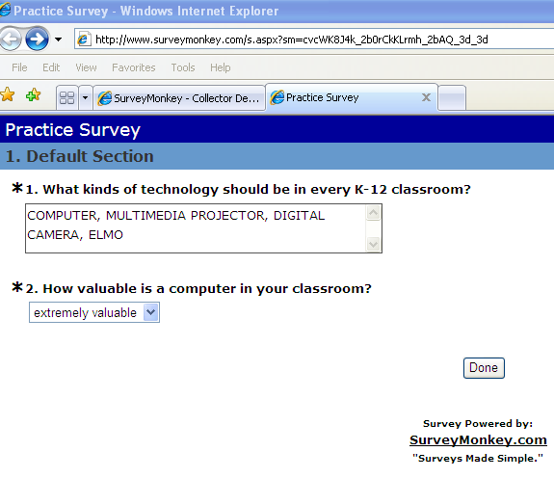

Return to Analyze results, view.

