Thing 3 – Blogging
EduBlogs Script
Adobe Connect Session 2
Jennifer Parker-Moore, Ed.D.

Have open: Edublogs.org; Edublogs Help Sheets, http://edublogs.misd.net
Prior to recording: http://edublogs.misd.net – note for Macomb County to use EduBlogs Campus
Discussion of what a Blog is- Web log
Educational applications – assignments, lessons, communication, collaboration
Blogging in Education Examples:
http://www.teachingtips.com/blog/2008/06/30/50-must-read-up-and-coming-blogs-by-teachers/

Help/How to link (document):
http://classroomblogging.files.wordpress.com/2008/06/edublogsetup.pdf

Discussion of terms:
- Post
- Page
- Avatar
- Static
- Categories
- tags

Edublogs.org
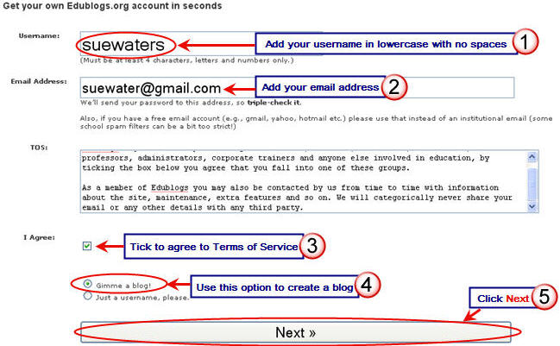

Check email and go to link – this will give login info, etc.
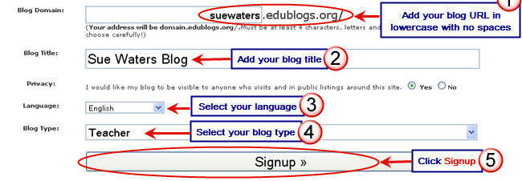
Videos and tutorials

Go to My Page –
Take a look at it – navigation, etc.
http://jpmoore67.edublogs.org/

DASHBOARD - drag and crop, collapse
  - Right Now
  - Quick Press
  - Recent Comments
  - Incoming Links
  - Screen Options

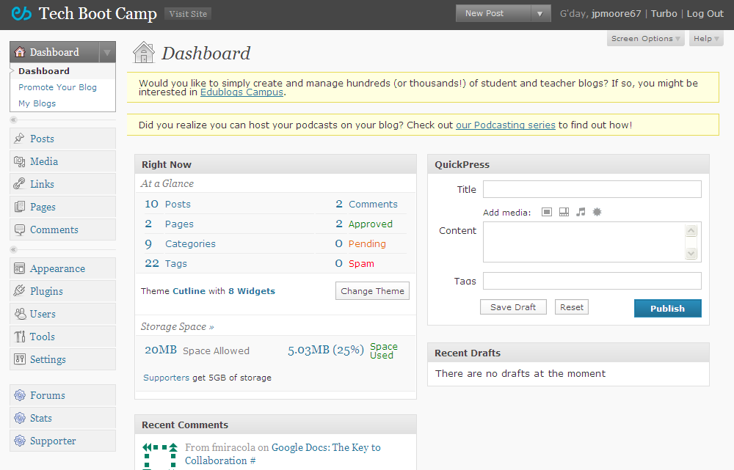

Side menu

Appearance
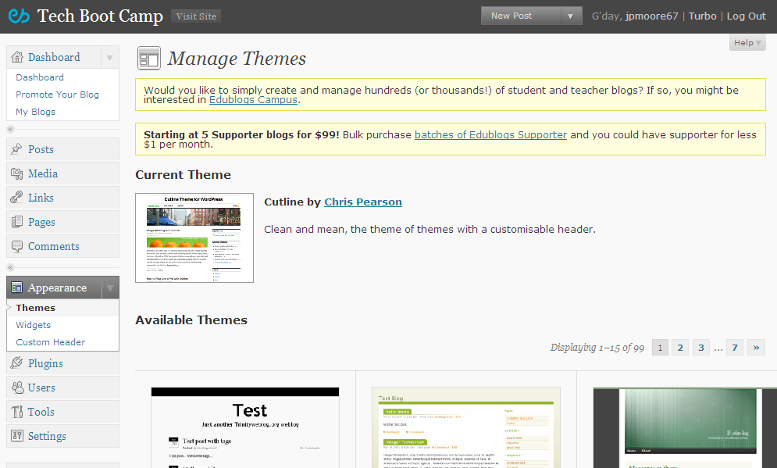

Themes
Preview vs. activate
Widgets
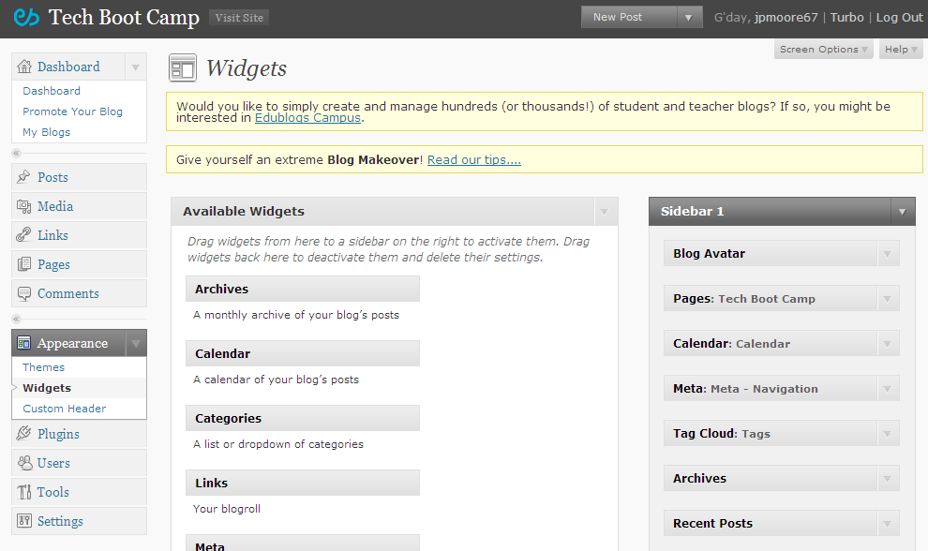
Archives, Blog Avatar, Calendar, Categories, Links, Meta, pages, Recent Comments, Search, Tag Cloud, Text

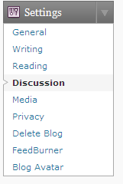
SETTINGS

Settings, General
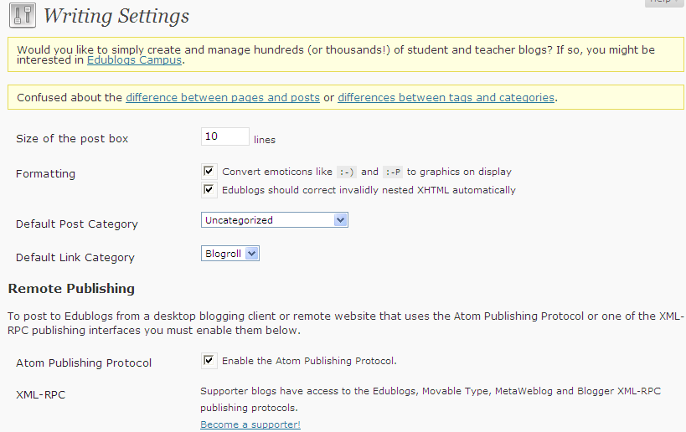

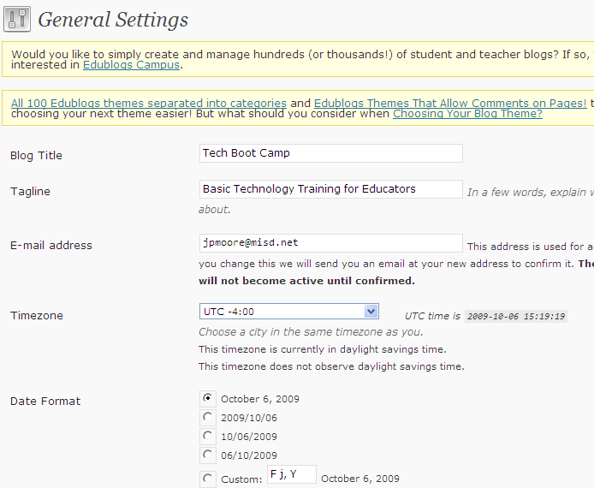
Settings, Writing – post size, formatting, categories

Settings, Reading – Current posts or static pages
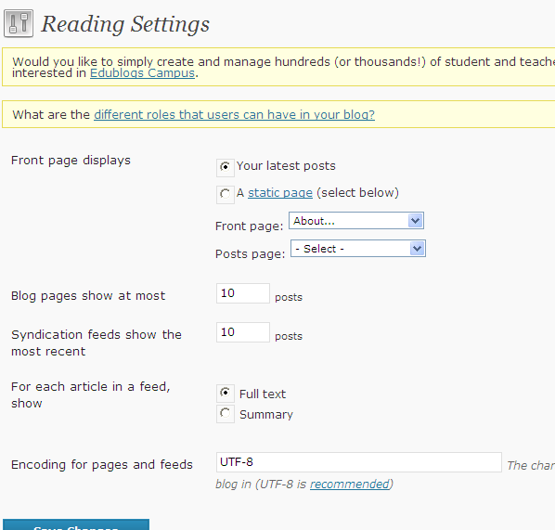

Settings, Discussion – moderated comments! Email me whenever, Administrator comments
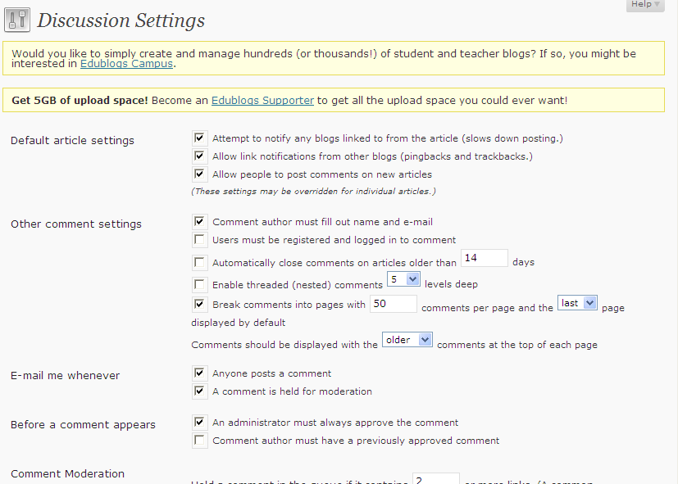
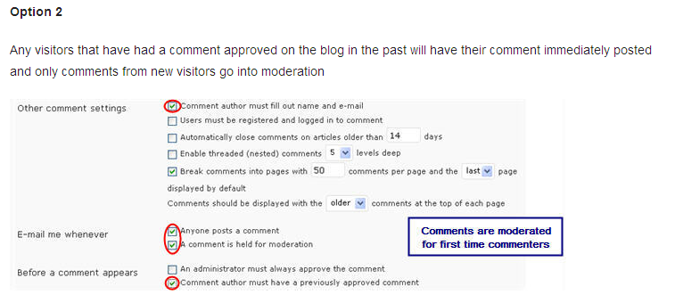
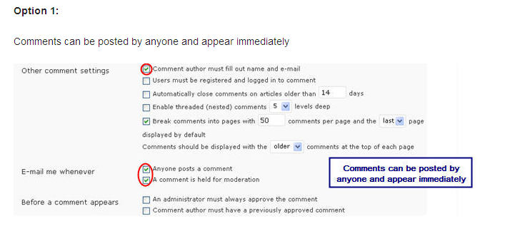
3 ways: Anyone/Immediate posting, Moderated – First timers, Before
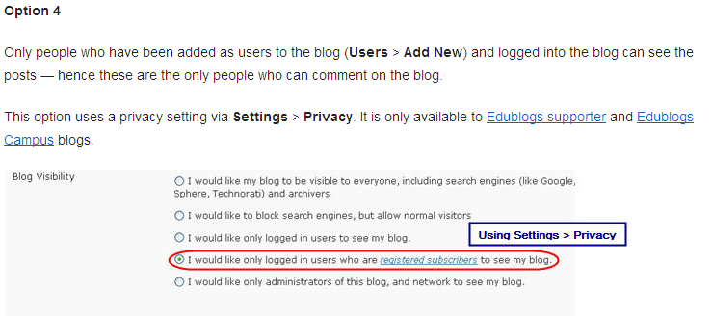
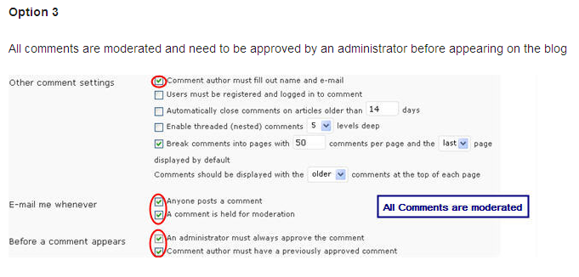

Settings, Media: size of images
Settings, Privacy: EDUBLOGS SUPPORTERS ONLY
Settings, Delete Blog
Settings, FeedBurner: EDUBLOGS SUPPORTERS ONLY
Settings, Blog Avatar: import image of yourself or other avatar.
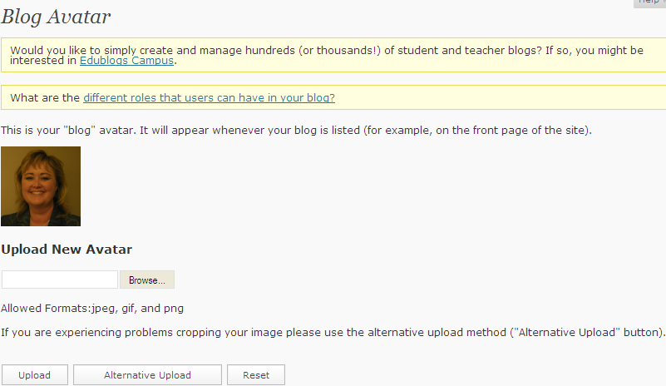

Pages vs. posts

PAGES – static (updated irregularly), no time stamps, no RSS feeds, can change order, no tags, no categories
POSTS – chronological order, dynamic (updated regularly), tags and categories, RSS feeds/subscriptions
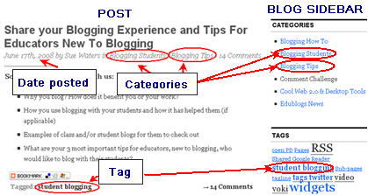
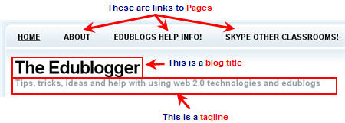

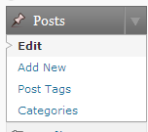
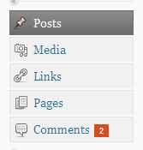
POSTS

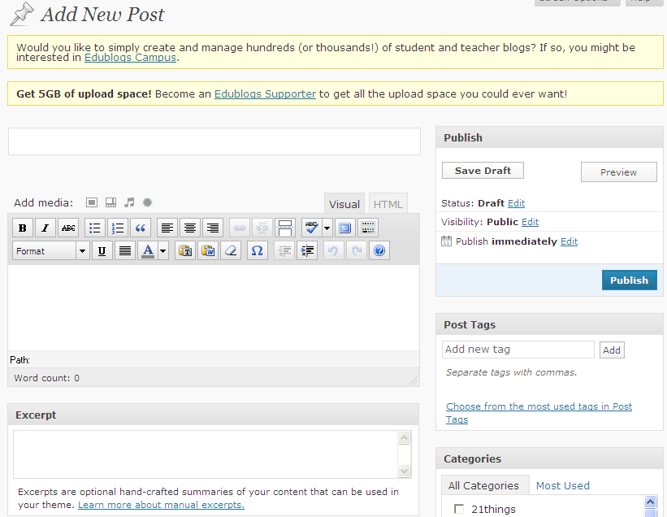
WRITE POST
Use ADD NEW or QUICK PRESS
POST, ADD NEW (from side menu)
ADD NEW: turn on the KITCHEN SINK, Tour this screen
Add title, content
Add tags
Add categories
Preview/Publish

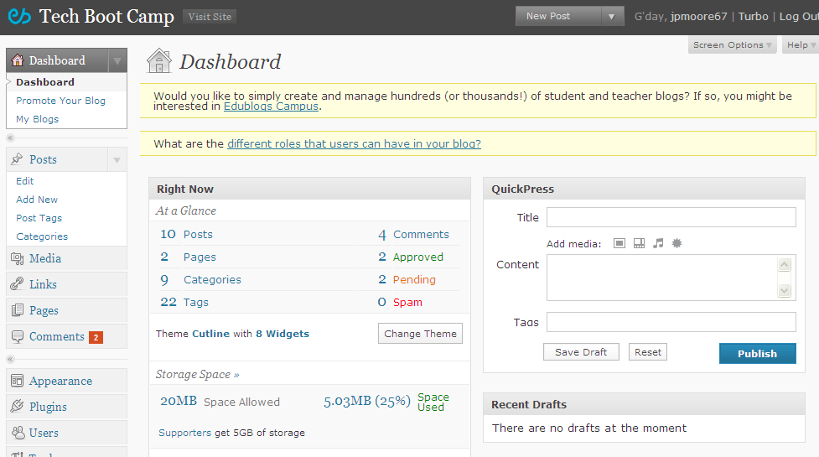
QUICK PRESS (from main Dashboard)
Add title, content
Add tags
Preview/Publish

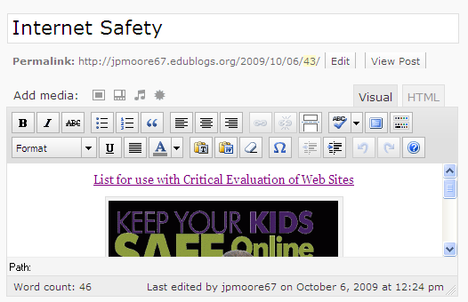
Inserting Images or other media:
Sample Post
Title: Internet Safety
Text: Internet safety is a priority, and teachers must do their best to promote appropriate use. Protecting our students from the dangers of the Internet can be challenging. Check out the resources at Web Wise Thinking
Insert link to Web Wise Thinking
http://techbootcampwebwise.weebly.com/
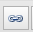
Insert picture for Keep Kids Safe Online
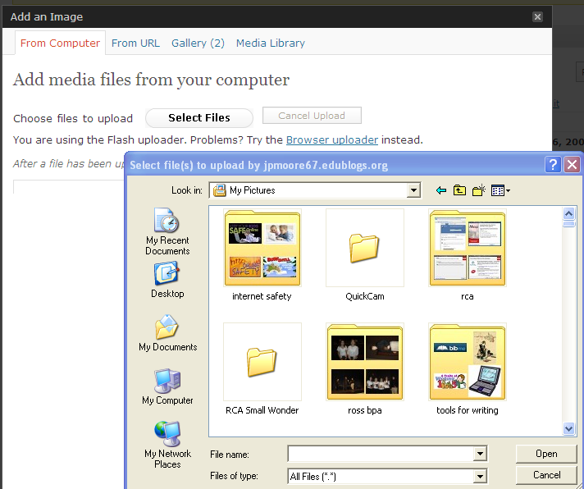

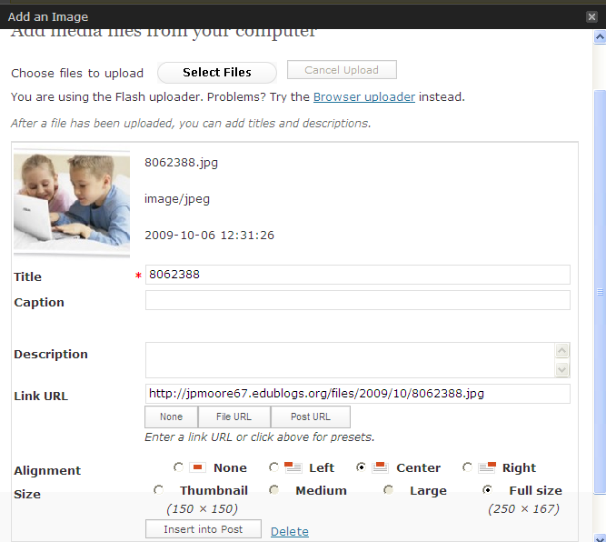
Add Caption, Description, Alignment, Size, insert into post

To Insert a Document
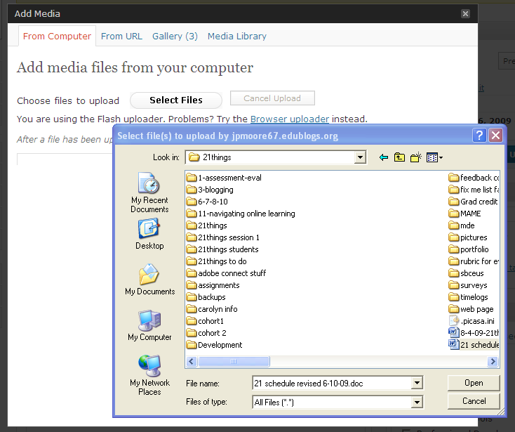

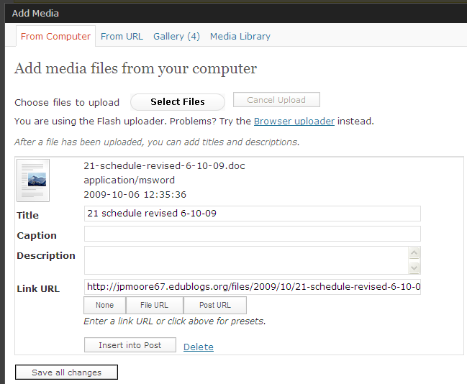
MAKE SURE TO CLICK ON FILE URL, GO TO MEDIA LIBRARY

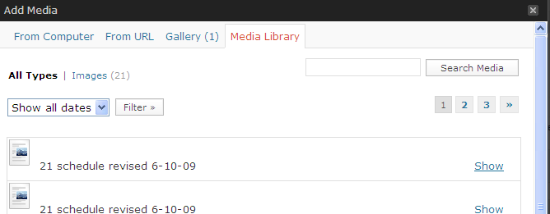

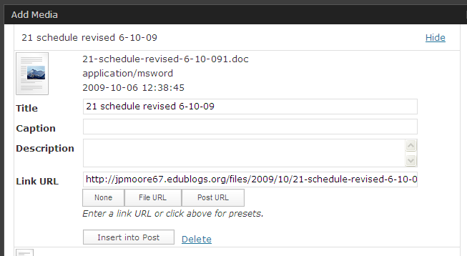

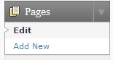
Add PAGES

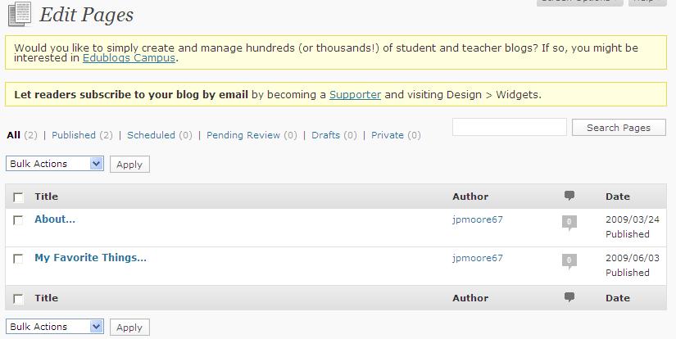

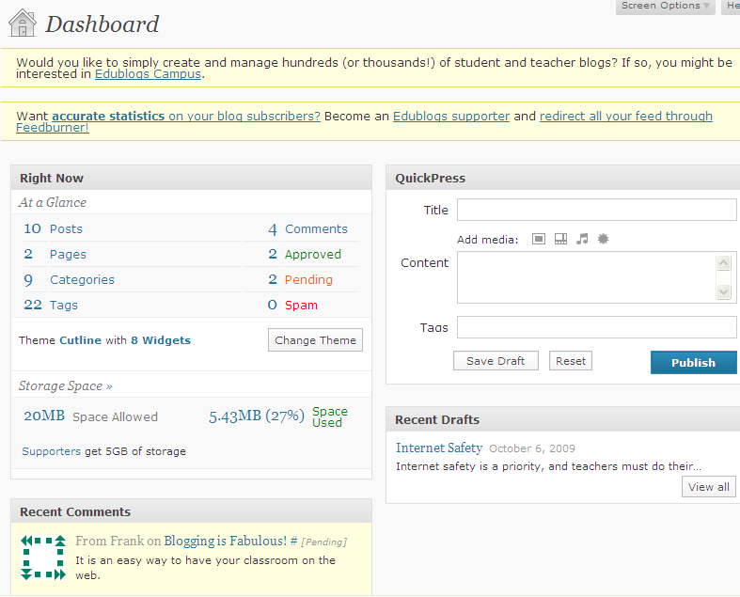
MODERATING COMMENTS
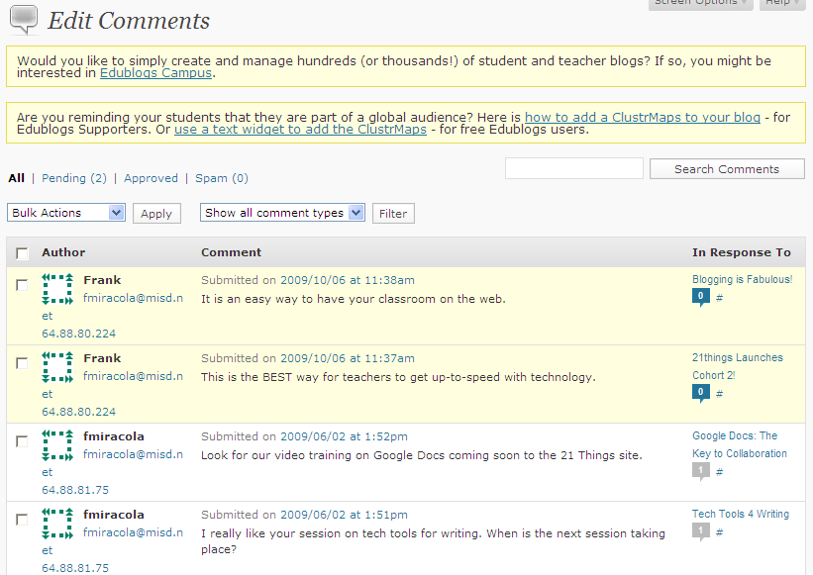
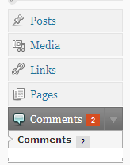
From the DashBoard

or from the left side menu

Manage comments: approve or disapprove, decline, etc.
Practice with the account you created at edublogs.org
- URL
- Email access
- Update profile
- Write a post
- View page
- Navigating the blog
- Edit posts
- Categories
- Create page
- Change look
- Comments – anyone, any registered Edublogs user, Moderated using fake emails
- Settings options

